BIT 4107 – Mobile Application Development
ENHANCED PROFESSIONAL STUDENT LOGBOOK
Student Name: Risper Chepngeno
Admission Number: BIT/2024/55500
School/Faculty: Computing and Informatics
Programme: Information Technology
Academic Year: 3
Semester: 2
Lecturer: Mr nyoro
Phone Number: 0794038472

Week 1: Introduction to Mobile Application Development
Tools/Software Used
Visual Studio code (VS Code):
Flutter SDK with Dart programming language
Google chrome browser-as runtime device simulation target
Figure1.1: Terminal Environment Output Displaying Verified Flutter and Dart Version Specifications
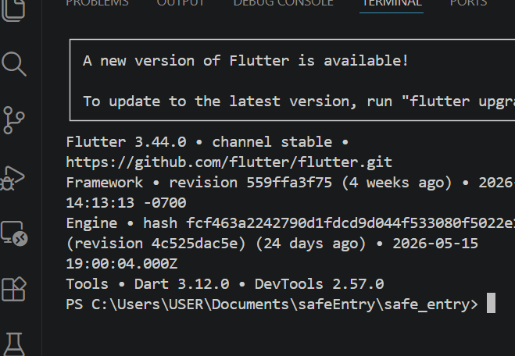

Practical Activities Undertaken
Screenshots/Evidence Attached (Yes)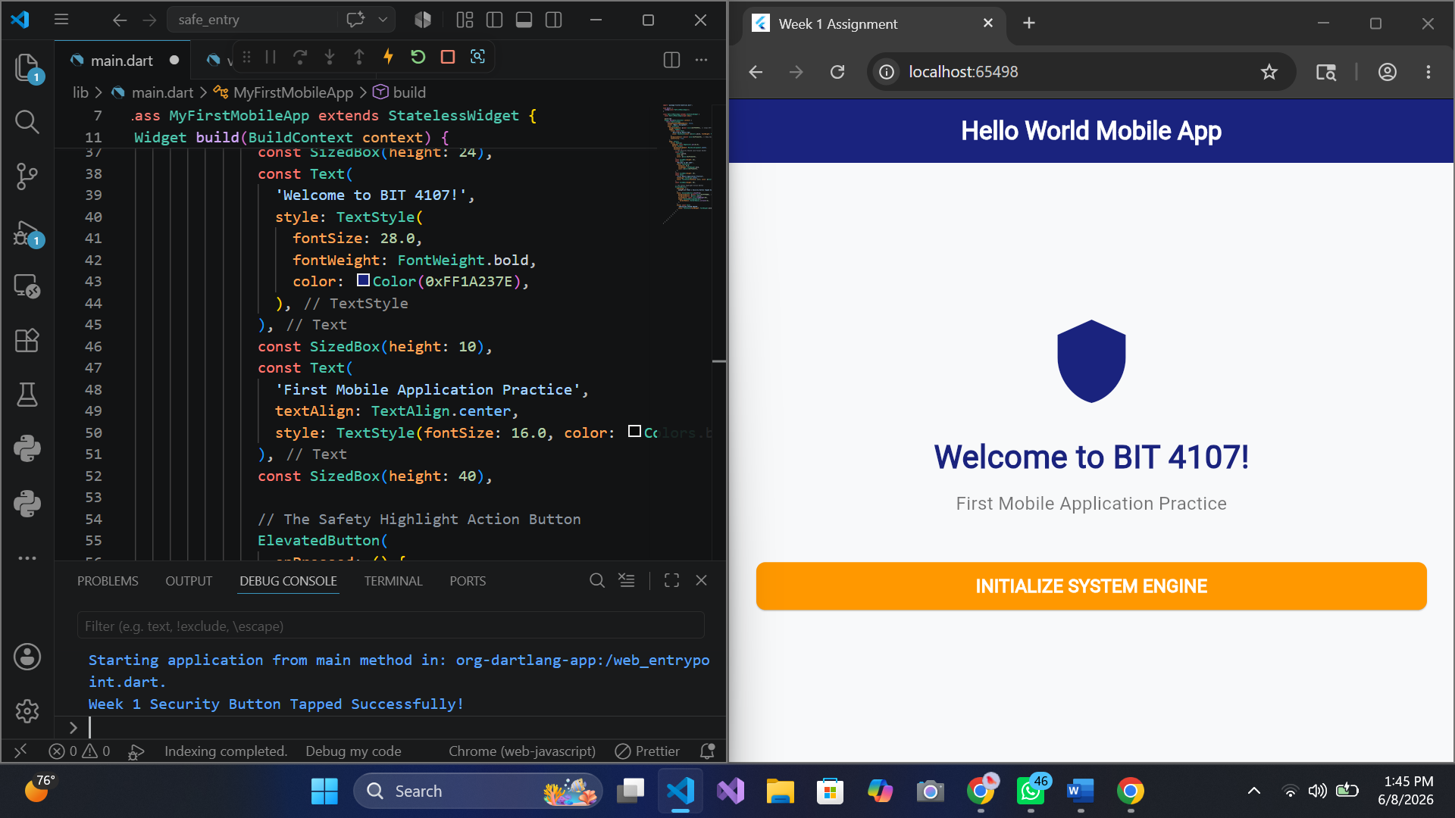
Personal Reflection

At first, I really struggled getting the system path to find Flutter, which was very frustrating. But fixing those VS Code errors—like deleting the broken widget_test.dart file and switching print to debugPrint—actually taught me how to debug terminal warnings. Seeing my navy shield and orange button finally light up on the screen was a real breakthrough.
Week 2:
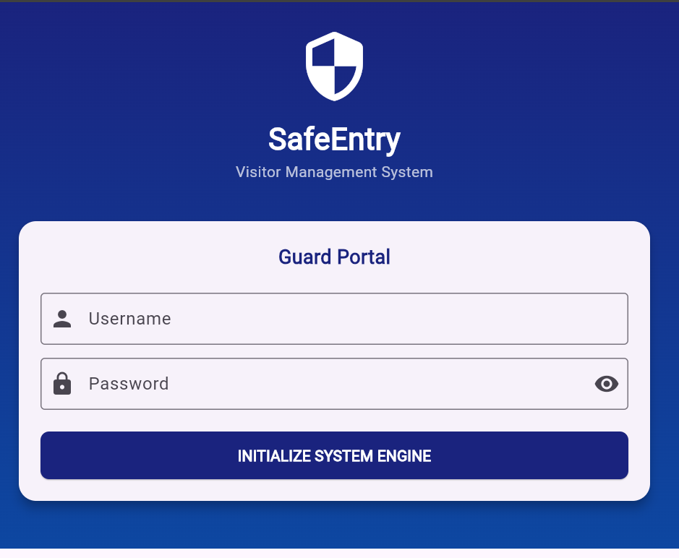
Figure 2.1 login page

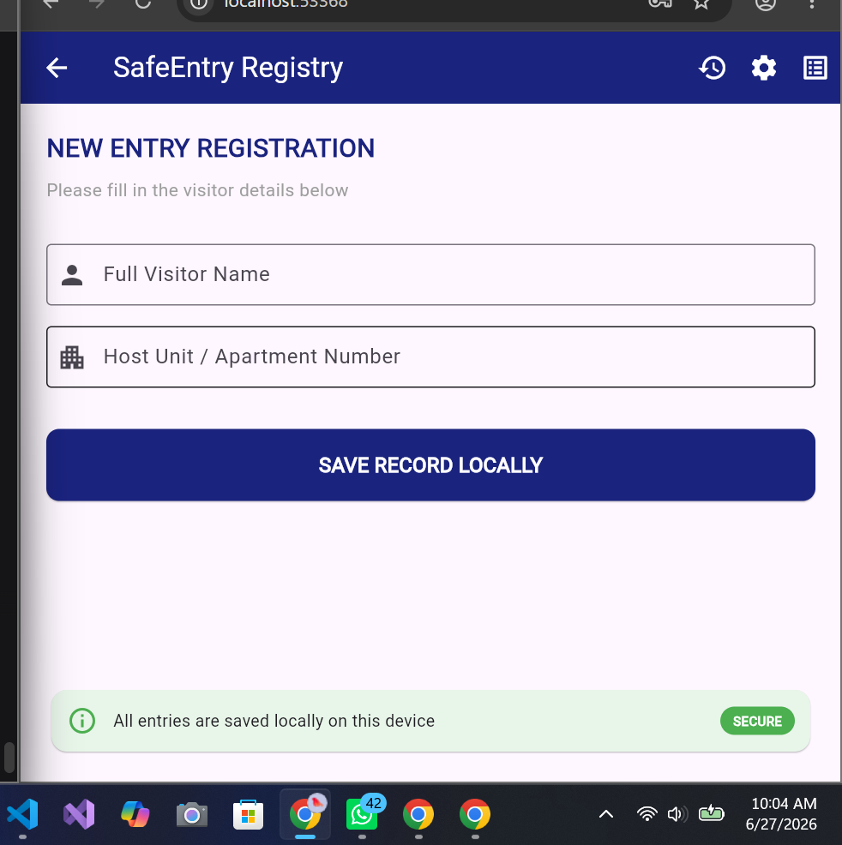
Figure 1.2 registration page
Personal reflection
I practiced on the syntax of dart language. It is similar to c and java so it did not take much of my time. being able to came up with the screens and navigate through it is worth it

Week 3: User Interface Design
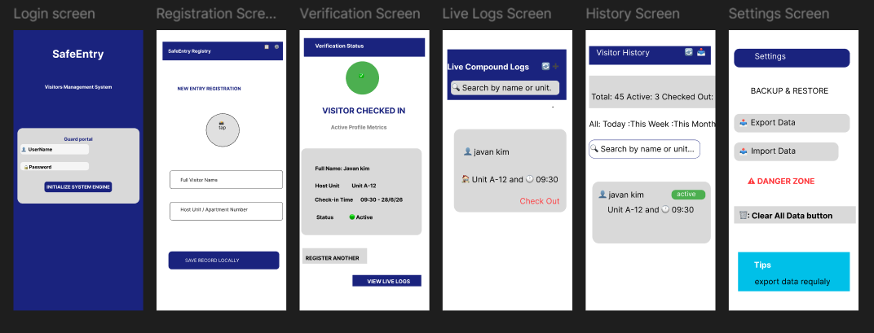
Figure 2.1 Figma design
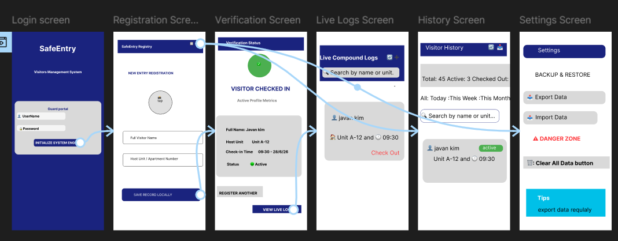
Figure 3.1: prototype linking of screens
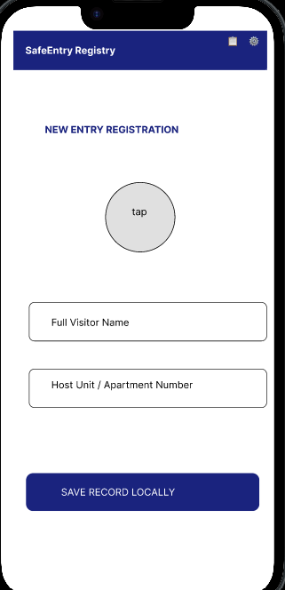
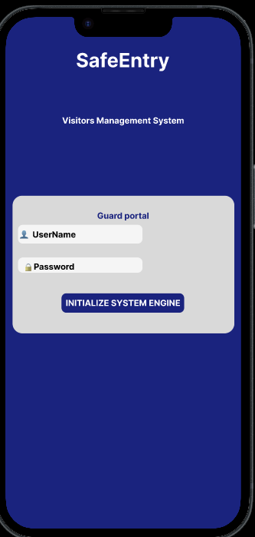
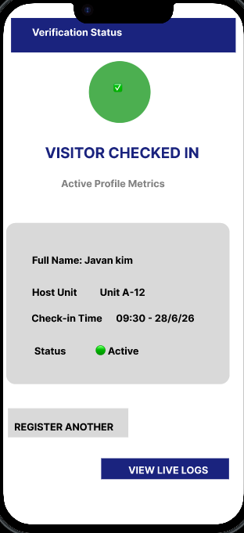
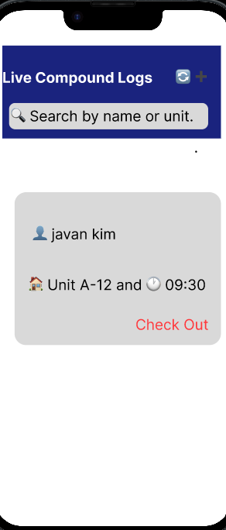
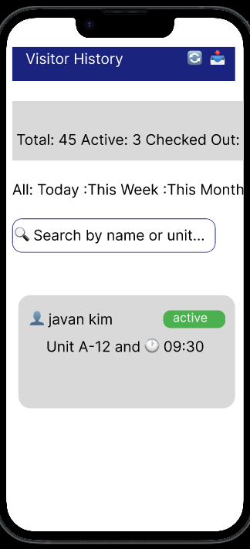
.
Figure 6.2 Figma Visual Interactive Prototype Wire Map Displaying Core Navigation Layout Flows and Brand System Themes

Week 4: Event Handling and User Interaction

Same as week 1
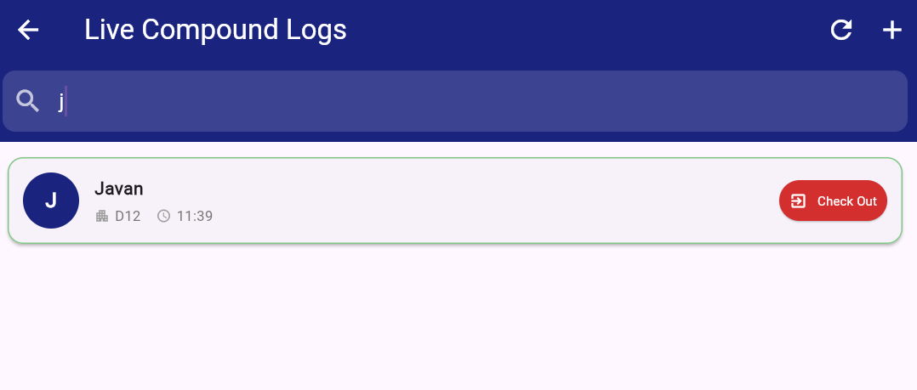
Figure 4User typing in search bar to filter visitors
Personal reflection
Working on event handlers and data saving this week is a big learning experience for me. At start I hit several bugs. I implemented the search fuctionality. The main challenge was the backward numbering issue of visitors, I fixed it by using index+1(incrementing), At last the SafeEntry registry finally works perfectly

Week 5: Data Management
Figure 5The Firebase Console Live Data Grid (The Cloud Proof)
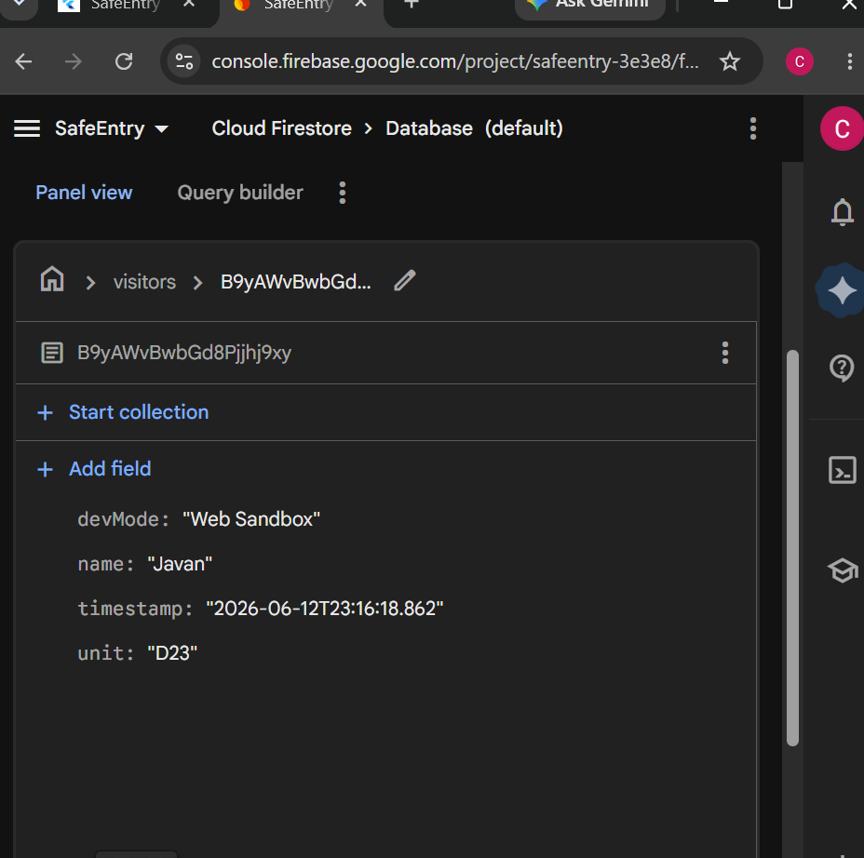

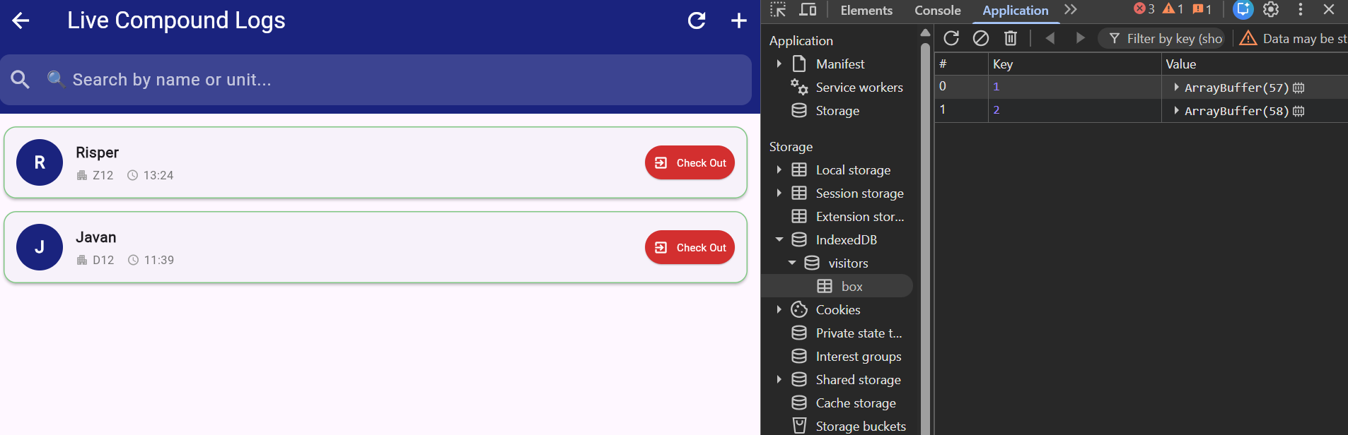
Figure 6.1 hives database
Personal Reflection:
Connecting my app to Google Firebase this week was a great learning experience. The trickiest part was fixing a windows permission issue that kept freezing my Google Chrome browser when I added the new cloud packages. I solved this by turning on Developer Mode in my system settings to clear the compiler link. Once I added my unique connection keys and set up the cloud database, watching my test visitor logs instantly pop up on the online Firebase grid in real-time was amazing. This week taught me how cloud data streams work,
I ended up using hive since it works on all platforms and since I had to run the app on website due to storage issues I could not use emulator but my phone and website

Week 6: Networking and APIs
Figure 7 Figure: API Service class for OpenWeatherMap integration
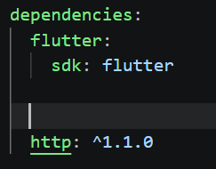
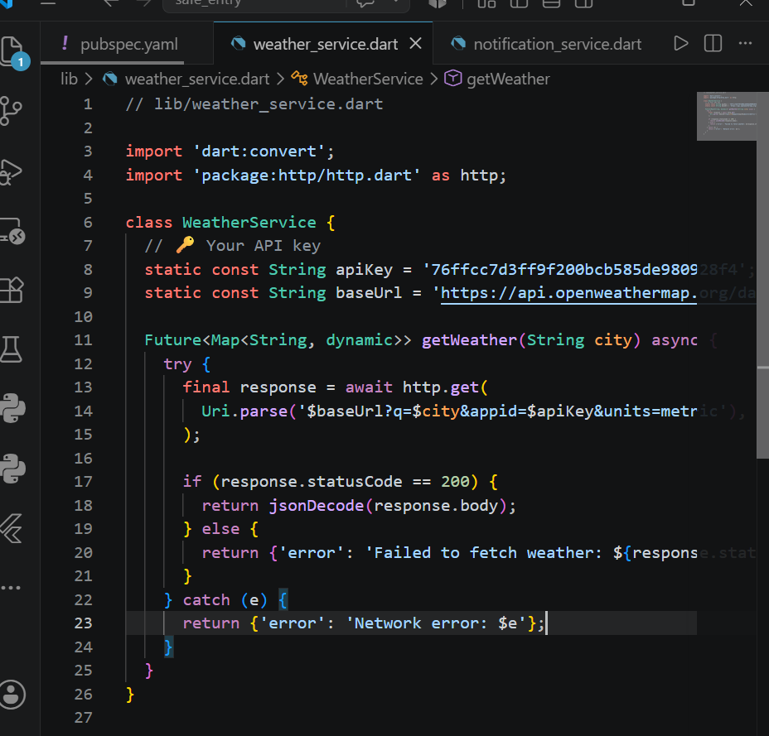

Figure 8 http package dependency

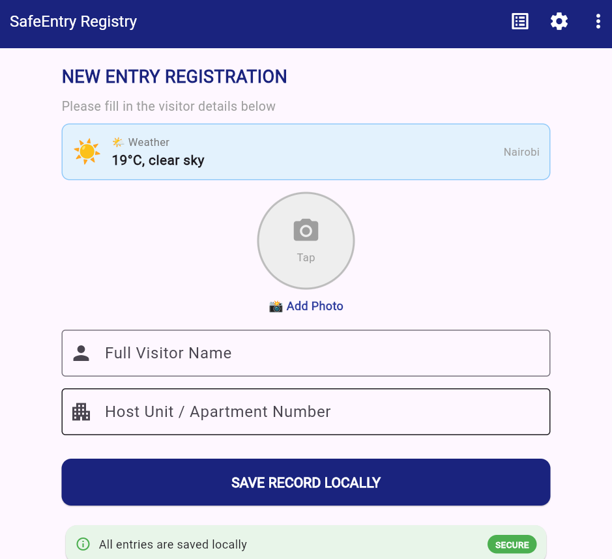

securely manage the OpenWeatherMap API key
Figure 9 Weather data displayed on Registration Screen

: Personal reflection
I gained experience making HTTP request using http package and learn to use json,and intergrated openweatherMap api
Week 7: Application Architecture

Same as week 1
FRONT-END CLIENT LAYER(Flutter UI view)

user inputs name and unit
Cache Layer(SQLite Database file and global runtime array)

BACKEND REMOTE STORAGE(Google cloud server)

Architecture Component Breakdown:
1. Front-End Client Layer: Built using Flutter UI layout elements (main.dart and registration_page.dart) to harvest visitor details via controllers and render them onto the display canvas.
2. Local Persistence Cache Layer: Combines an offline SQLite structural database file with a global runtime array . This guarantees 0-latency entry registrations at the estate gate and acts as an immediate safety net if local internet drops.
3. Backend Cloud Layer: A live remote storage node hosted on Google Cloud servers that receives data payloads via secure API network communication streams, assigns unique document tracing IDs, and preserves central records for system administrators.
Week 8: touch Gesture handling
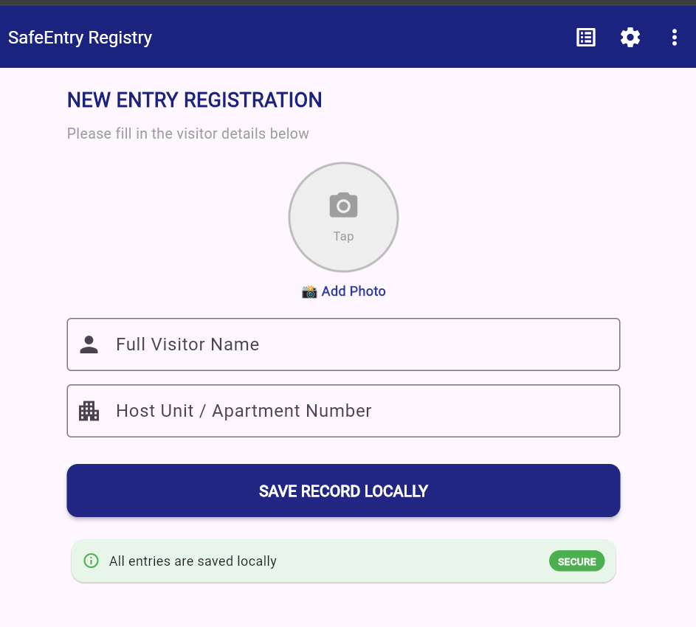
Figure 10 photo capture-users tap circular area to open camera
Personal reflection
I learned how to access device using image_picker package and understood touch detection using gesturdetection camera did work on a browser so I had to test on my phone. I had to store the image path in database due to storage issues.
Storing images was challenging
- Solution: I stored the photo path instead of the image itself in the

Semester Project Tracking

Project Title

Project Objectives

Project Requirements

Development Milestones

Testing Results

Lessons Learned

Future Improvements

End of Semester Reflection

Summary of Skills Acquired

Most Interesting Topic

Major Challenges Faced

How Challenges Were Overcome

Professional Growth Achieved

Overall Course Experience

Final Approval
Student Name: __________________________
Student Signature: ______________________
Date: _________________________________
Lecturer Name: _________________________
Lecturer Remarks: _____________________
Date: _________________________________

